Trojan-Spy:Styricka

0a7aa79a8b8824b5e21f7f0b9b30a3789b3ca200_e9fd83e9b4f995c5c73f34bfce0ca3e52371b1d5738e8bea5236e3e2ee0137e7

1. Malware&Normal comparison

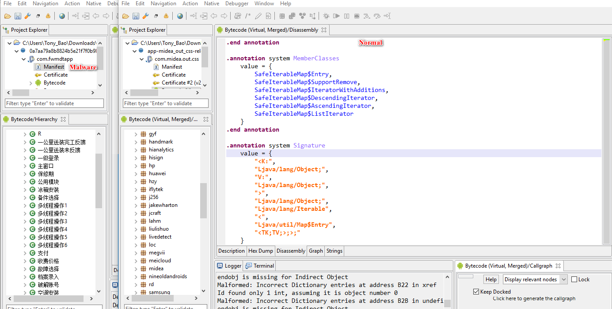

Normal: http://apps.midea.com/pcNew.html



1. Pay and become VIP

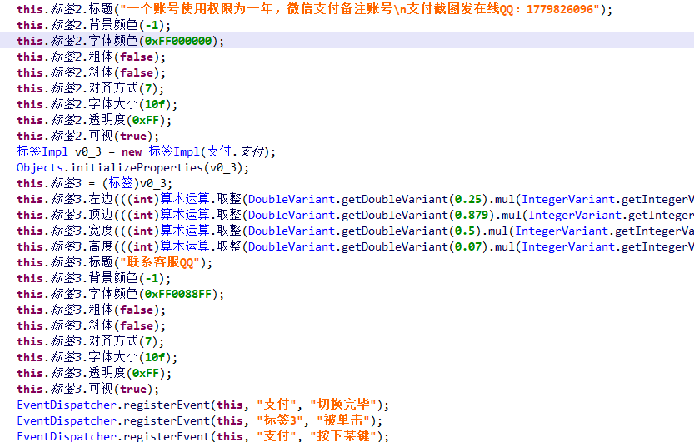

3. Communicate with QQ

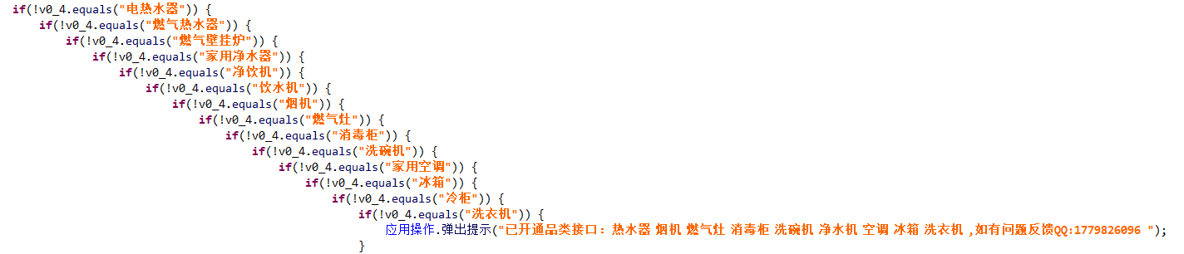

4. Crack engineer account

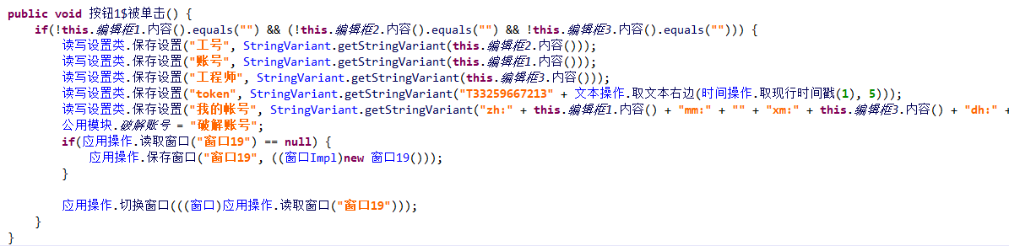

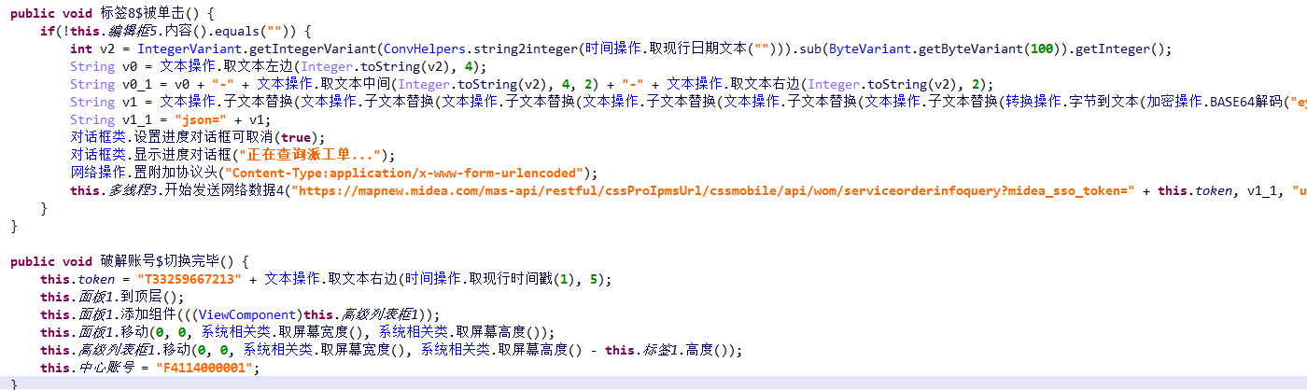

5. Runtime

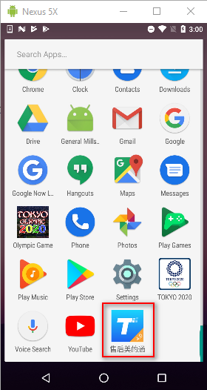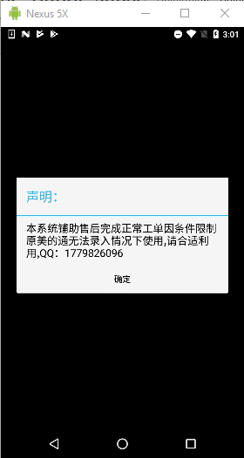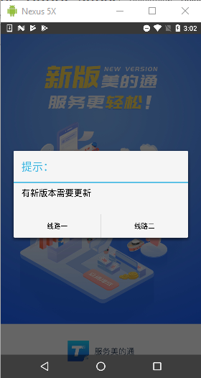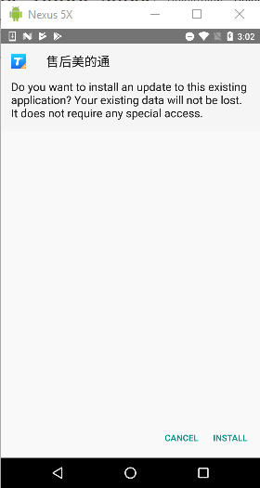

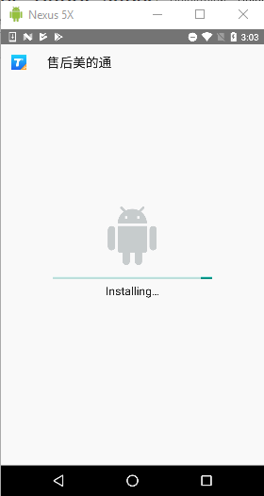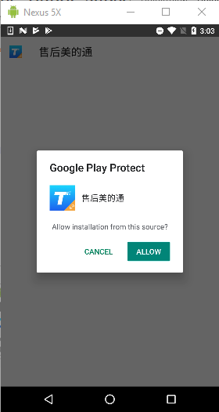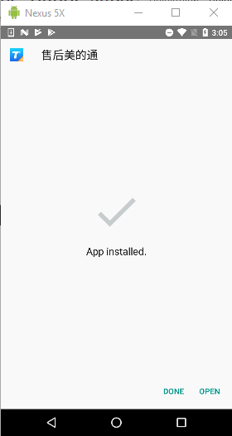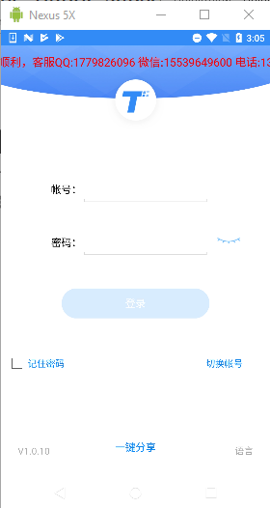

563063b80600df642de6fd4b99bd5e7620fc0f10_282e6ba1c6ae47d9a649d76844f00d38c35e837211be1503a3e7759c194a8b9f

E Language Demo

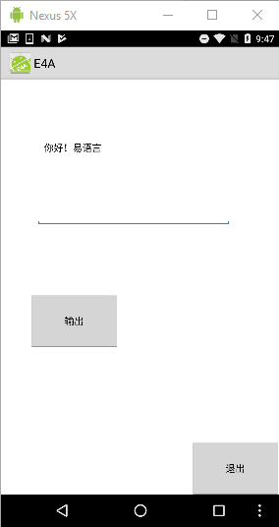

fd79e80da271eef34e7de9f63748c12b386db0e8_b8aa96ab8fc0711227fc861c6f0704dc82057121fc5e07e729c09fe39322779d

sample is old, sample stays in this activity.

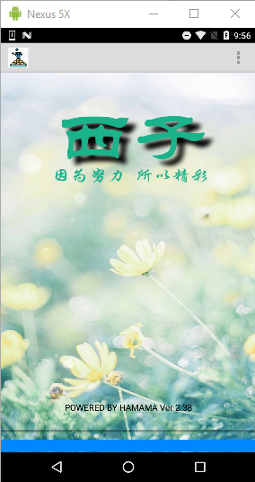

fc35aa047c8b6cdadcff051bc35c92a0911c02c6_41405d2af26caa053b0240b24e405c7fd458d347039b1c1fbf7bb9cd81d57189

Spy bank sms/phone

